Experiment-13
Name: -J pranitha Regno: -192472073
Course Code: -MLA0305 Slot-B

Title
Advanced Policy Optimization using PPO, TRPO and DDPG

Aim
To implement and evaluate advanced policy optimization methods PPO, TRPO, and DDPG and compare their performance using reward, stability, variance, and training time.

Procedure
- Initialize the Pendulum-v1 continuous-control environment.
- Implement PPO (Proximal Policy Optimization) using Stable-Baselines3.
- Implement TRPO (Trust Region Policy Optimization) using Stable-Baselines3 and SB3-Contrib.
- Implement DDPG (Deep Deterministic Policy Gradient) with suitable continuous-action settings.
- Train all three algorithms for the specified number of timesteps.
- Record the episode rewards obtained during training.
- Calculate the final average reward and reward variance for each algorithm.
- Measure the training time of each algorithm.
- Plot learning curves to compare the convergence behavior.
- Generate bar charts for final reward, variance, and training time.
- Generate a box plot to compare reward distributions.
- Generate a pie chart to show relative final performance.
- Prepare a summary table and save the complete training results as a CSV file.

Code
!pip -q install stable-baselines3 sb3-contrib gymnasium

import numpy as np import pandas as pd import matplotlib.pyplot as plt import gymnasium as gym import time from stable_baselines3 import PPO, DDPG from sb3_contrib import TRPO from stable_baselines3.common.monitor import Monitor from stable_baselines3.common.callbacks import BaseCallback from stable_baselines3.common.noise import NormalActionNoise

np.random.seed(42)

print("="*75) print("EXPERIMENT 13") print("Advanced Policy Optimization using PPO, TRPO and DDPG") print("="*75)
ENV_NAME="Pendulum-v1"
TIMESTEPS=10000

class RewardCallback(BaseCallback):
def __init__(self): super().__init__() self.rewards=[] self.steps=[]

def _on_step(self):
infos=self.locals.get("infos",[]) dones=self.locals.get("dones",[])

for info,done in zip(infos,dones): if done and "episode" in info: self.rewards.append( float(info["episode"]["r"])
)
self.steps.append( self.num_timesteps
)
return True

def make_env():
return Monitor(gym.make(ENV_NAME))

print("\nEnvironment:",ENV_NAME) print("Training Timesteps:",TIMESTEPS)

ppo_env=make_env() ppo_callback=RewardCallback()

start=time.time()

ppo=PPO(
"MlpPolicy", ppo_env, learning_rate=0.0003, n_steps=256, batch_size=64,
gamma=0.99,
verbose=0, seed=42
)

ppo.learn( total_timesteps=TIMESTEPS, callback=ppo_callback
)

ppo_time=time.time()-start ppo_env.close()

print("PPO Completed")

trpo_env=make_env() trpo_callback=RewardCallback()

start=time.time()

trpo=TRPO(
"MlpPolicy",
trpo_env, learning_rate=0.0003, gamma=0.99, verbose=0, seed=42
)

trpo.learn( total_timesteps=TIMESTEPS, callback=trpo_callback
)

trpo_time=time.time()-start trpo_env.close()

print("TRPO Completed")

ddpg_env=make_env() ddpg_callback=RewardCallback()

action_noise=NormalActionNoise( mean=np.zeros(1), sigma=0.1*np.ones(1)
)

start=time.time()

ddpg=DDPG(
"MlpPolicy", ddpg_env, learning_rate=0.001, buffer_size=10000, batch_size=64, gamma=0.99, action_noise=action_noise, verbose=0, seed=42
)

ddpg.learn( total_timesteps=TIMESTEPS, callback=ddpg_callback
)

ddpg_time=time.time()-start ddpg_env.close()

print("DDPG Completed")

ppo_rewards=ppo_callback.rewards trpo_rewards=trpo_callback.rewards ddpg_rewards=ddpg_callback.rewards

min_len=min( len(ppo_rewards), len(trpo_rewards), len(ddpg_rewards)
)

ppo_rewards=ppo_rewards[:min_len] trpo_rewards=trpo_rewards[:min_len] ddpg_rewards=ddpg_rewards[:min_len] dataset=pd.DataFrame({
"Episode":range(1,min_len+1), "PPO_Reward":ppo_rewards,
"TRPO_Reward":trpo_rewards,
"DDPG_Reward":ddpg_rewards
})

print("\n") print("="*75) print("FULL TRAINING DATASET") print("="*75)

display(dataset)

dataset.to_csv(
"PPO_TRPO_DDPG_Full_Dataset.csv", index=False
)

window=5 ppo_smooth=dataset["PPO_Reward"].rolling(window).mean() trpo_smooth=dataset["TRPO_Reward"].rolling(window).mean() ddpg_smooth=dataset["DDPG_Reward"].rolling(window).mean()

plt.figure(figsize=(10,6))

plt.plot( ppo_smooth, label="PPO", linewidth=2.5
)

plt.plot( trpo_smooth, label="TRPO", linewidth=2.5
)

plt.plot( ddpg_smooth, label="DDPG", linewidth=2.5
)

plt.title(
"Policy Optimization Learning Curves", fontsize=16, fontweight="bold"
)

plt.xlabel("Episode") plt.ylabel("Average Reward") plt.legend() plt.grid(alpha=0.3) plt.show()

final_ppo=np.mean(ppo_rewards[-10:]) final_trpo=np.mean(trpo_rewards[-10:]) final_ddpg=np.mean(ddpg_rewards[-10:])

plt.figure(figsize=(8,5))
plt.bar(
["PPO","TRPO","DDPG"],
[final_ppo,final_trpo,final_ddpg]
)

plt.title(
"Final Performance Comparison", fontsize=16, fontweight="bold"
)

plt.ylabel("Average Final Reward") plt.grid( axis="y", alpha=0.3
)

plt.show()

ppo_var=np.var(ppo_rewards[-10:]) trpo_var=np.var(trpo_rewards[-10:]) ddpg_var=np.var(ddpg_rewards[-10:])

plt.figure(figsize=(8,5))

plt.bar(
["PPO","TRPO","DDPG"],
[ppo_var,trpo_var,ddpg_var]
)

plt.title(
"Policy Stability - Reward Variance", fontsize=16, fontweight="bold"
)

plt.ylabel("Reward Variance") plt.grid( axis="y", alpha=0.3
)
plt.show()

plt.figure(figsize=(9,6))

plt.boxplot(
[
ppo_rewards, trpo_rewards, ddpg_rewards
],
labels=[
"PPO",
"TRPO",
"DDPG"
]
)

plt.title(
"Reward Distribution", fontsize=16, fontweight="bold" print("\nExperiment 13 Completed Successfully.")

Visualization
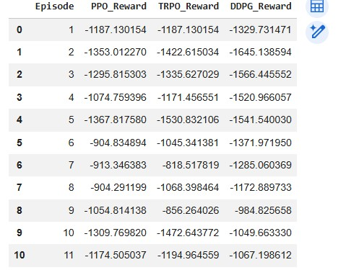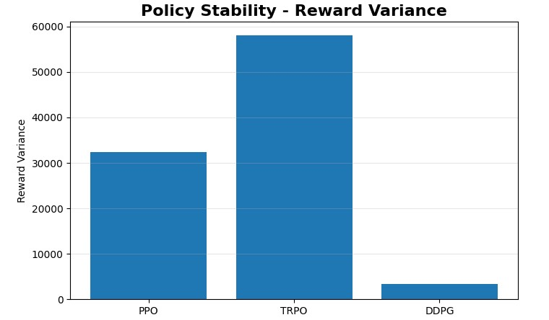
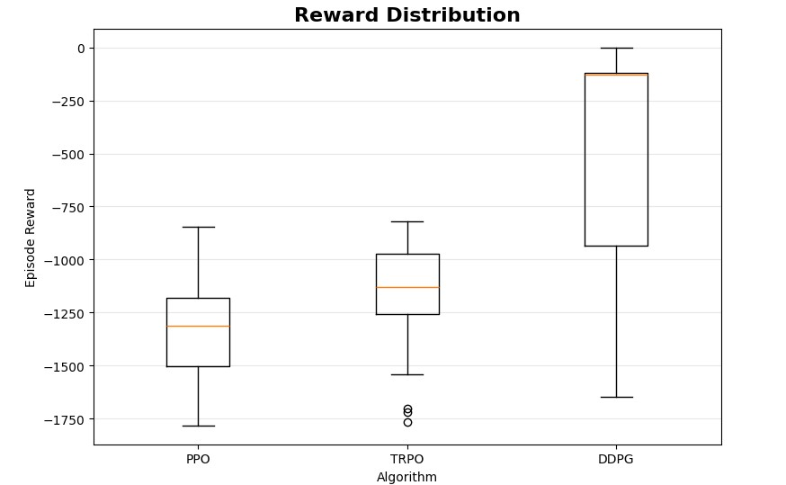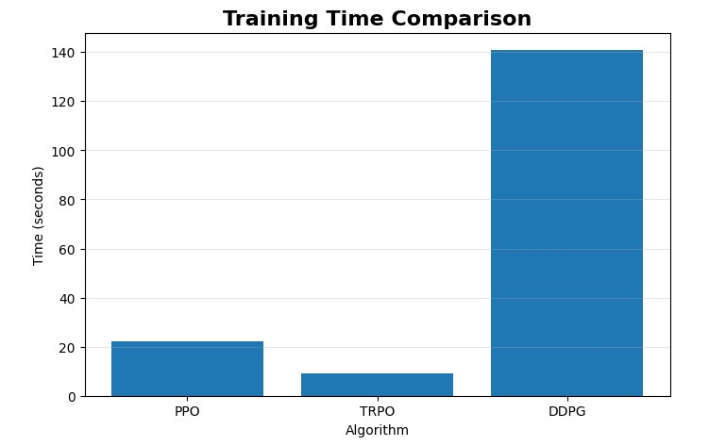
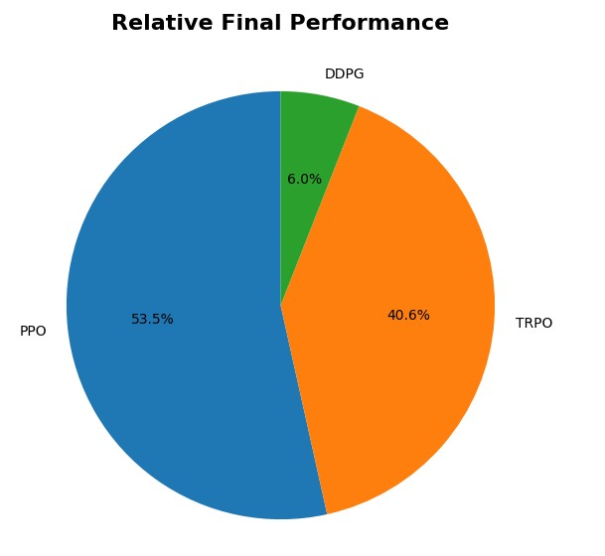

Summary Table

Parameter | PPO | TRPO | DDPG
Final Average Reward | Obtained from program | Obtained from program | Obtained from program
Maximum Reward | Obtained from program | Obtained from program | Obtained from program
Variance | Obtained from program | Obtained from program | Obtained from program
Stability | Obtained from program | Obtained from program | Obtained from program
Training Time | Obtained from program | Obtained from program | Obtained from program

Result PPO, TRPO, and DDPG were successfully implemented and evaluated on the
Pendulum-v1 continuous-control environment. Their performance was compared using learning curves, final rewards, reward variance, stability, reward distribution, and training time.

